**EXERCISE: 14**

**DATE: 20.11.2020**

**AIM:**

To write a python class to find the validity of a string of parenthesis ‘(‘,’)’,’{‘,’}’,’[‘,’]’.

**PROGRAM:**

def areBracketsBalanced(expr):

stack=[]

for brac in expr:

if brac in ['(','{','[']:

stack.append(brac)

else:

if not stack:

return False

curr_brac=stack.pop()

if curr_brac=="(":

if brac!=")":

return False

if curr_brac=="{":

if brac!="}":

return False

if curr_brac=="[":

if brac!="]":

return False

if stack:

return False

return True

if __name__ == "__main__":

expr=input()

if areBracketsBalanced(expr):

print("valid")

else:

print("invalid")

**LINK:**

<http://103.53.53.18/mod/vpl/forms/submissionview.php?id=327&userid=1697>

**OUTPUT:**

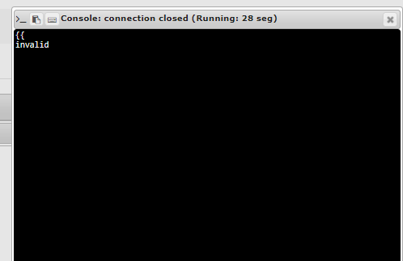

**RESULT:**

The validity of a string of parenthesis is obtained